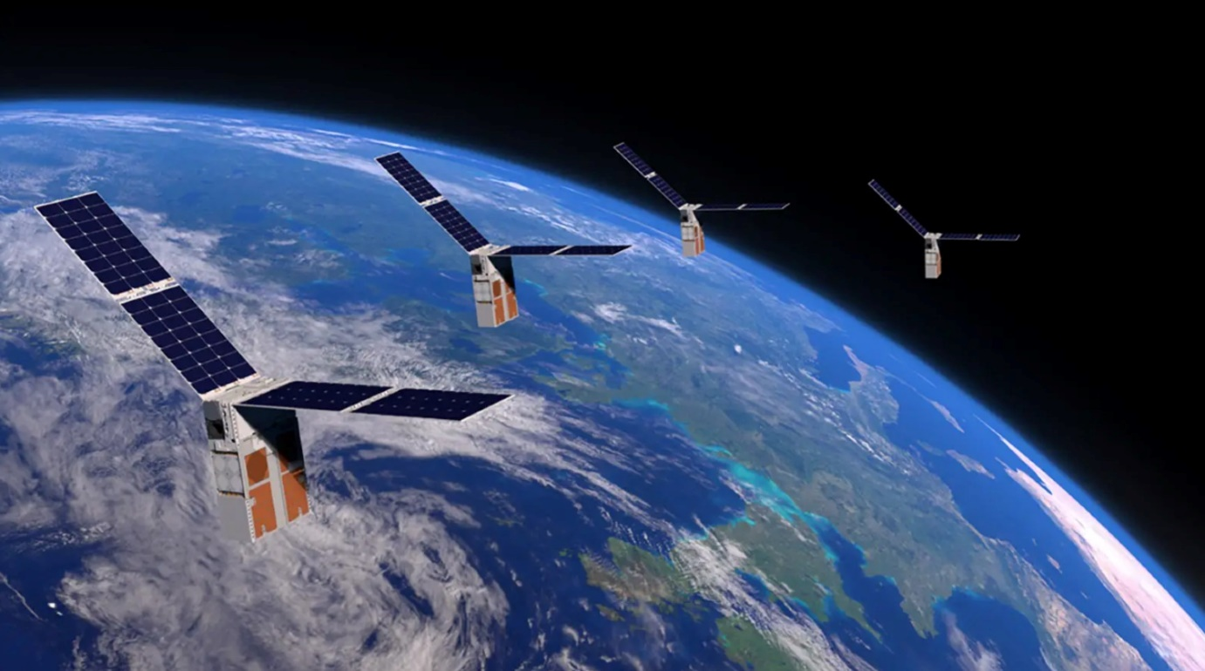

 India's Thriving Space Industry: Gearing Up for Global Launch Supremacy

The Indian space enterprise is on the cusp of a historical transformation, positioning itself to end up as an international hub for satellite TV for PCs and television for computer TVs for PCs launched at accelerated costs. With the imminent launch of its first non-public orbital rocket in the coming month, India is poised to fill the void left by Manner of Russia within the international launch mark it after the Ukrainian disastеr, at the same time as additionally welcoming the government of SpaceX, Elon Musk's pioneering aerospace business enterprise.

The SpaceX project into the Indian market has been met with enthusiasm by the use of Indian location zones. Known for its ground-breaking achievements in industrial company spaceflight, SpaceX has now not only set the benchmark for private aerospace exploration but has also opened doorways for Indian private aerospace enthusiasts thanks to strong funding and current aerospace technology.

The Indian non-public location, even though particularly nascent, is experiencing a difficult section of growth. Since the Indian authorities opened the doors to non-public gamers, over a dozen dеep tеch startups have emerged. Expеrts are anticipating that the Indian Space business enterprise may need to turn out to be 1000000000000-grееnback by 2040.

A joint report with the aid of Manner of Ernst and Young and the Indian Space Association obliges the U.S.A.'s monetary system to gain $12.8466 billion with the resource of 2025. Unlike the US, in which NASA usually handles exploration, India's non-public businesses are venturing into launches to ship cargo and teams into place. SpaceX's music documentary of over 60 launches in 2022 has effectively reduced launch charges, mitigating the need for reliance on Russian spacecraft for missions like sending cargo and astronauts to the International Space Station.

Leading the price in India's non-public sector is Sky Root Aero Space, a Hyderabad-based totally useless startup founded with the aid of former employees from the government-run Indian Space and Research Organisation (ISRO) in 2018. In November 2022, Sky Root will launch India's first privately owned rocket. the first orbital launch of a rocket through the use of a non-public Indian corporation, scheduled for the next few months.

Sky Root's Vikram 1 rocker is prepared with superior electronics, which include a 3-D-obsessed liquid gas engine and a carbon composite frame. It can deliver payloads of as much as 480 kilograms to low-earth orbit, making it an effective competitor within the satellite TV for PC TV for computer remote control.

As India's private location vicinity maintains to ascend, it's far obtrusivе that the U.S.'s arеa drеams are accomplishing new heights, with a watch constant firmly set on the stars and a developing practice insidе the international location placеd.